Requestor:

VW – Etracker request:

**From:** Ming Fong, Chong   
**Sent:** 23 December 2015 11:18  
**To:** Chan, Pei-Fong  
**Subject:** e-tracker- treatment flag

Dear Pei Fong,

Can you please set the treatment default→ YES only applicable to destination **AUSYD** and DEHAM

Other ports set as NO.



Thanks and Best Regards,

Chong Ming Fong (Ms)Executive, Customer Service

Contract Logisctics/SCM, Operations

Schenker Singapore (Pte) Ltd

2 Changi South Avenue 1

Singapore 486149

Phone (DID): +65 6245 5326  Fax: +65 6545 7217

Mobile: +65 98532635

Suggested solution:

**From:** Chan, Pei-Fong   
**Sent:** Wednesday, 30 December, 2015 10:13 AM  
**To:** Go, Yusming  
**Cc:** Tjan, Henry  
**Subject:** FW: e-tracker- treatment flag default request.

Hi Yusming,

We have one change request for VW e-tracker as below:

Request to set default treatment flag to “Yes” for destination port  ( Tracking_HDR.PortofDestination = AUSYD and DEHAM )

Other port set to “NO”

**Suggested solution**

1. Add codelkup setup – Listname = “PORTTRMT”, setup list of Port that required treatment flag set default as ‘YES’
2. Etracker changes – when add/insert new container detail line – validate if ProjectID = ‘VW’ and PortofDestination exists in Codelkup.code where Codelkup.ListName = “PORTTRMT”, then auto flag the   
   treatment flag as ‘Yes’ else set as ‘No’
3. Code master – List Name dropdown – change to get from Table **CODELIST.Listname**

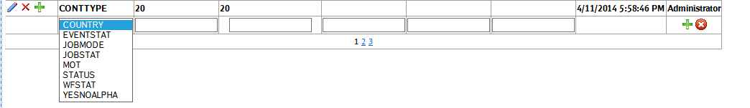

please advise if it’s alright , we will request user to raise ASR for this then. Thanks.

